Chapter 1
INTRODUCTION

  - Background of the Study
Traffic accidents are commonly accepted as an occurrence involving one or more transportation vehicles in a collision that results in traffic congestion, property damage, injury, or death. Traffic accidents occur all over the world. Where there are vehicles, traffic accidents are bound to happen. Nearly 3,500 people die due to these traffic accidents every day. A lot of people get injured or disabled because of such accidents. Numbers of casualties reach up to tens of millions per year. Children, pedestrians, cyclists and the elderly are the road users that are most vulnerable to such accidents. This is why it is considered as the main negative impact of modern road transportation today. Several people are affected especially the ones involved in the accident, their families, friends, and relatives, and the precious time of those in traffic. It is also stated in an article from the literature reviews that rapid growth of traffic accident rate has been recorded in the national statistical record by Land Transportation Office (LTO). Increasing growth of accident rate challenges the proponents to aid the problem. Local governments and communities, especially in third world countries, desperately need a traffic accident management information system which will reduce the traffic accident rate, prevent traffic congestion, and save more lives.
According to a number of articles in the literature review, several countries have been finding solutions to the increase in traffic accident rates and have succeeded. Solutions that proved to be effective are computer-based systems. It is said that Traffic Management System is one of the most critical developments a government of a country or local government of a city has to establish to satisfy the demand of the increasing incidents on the road. The main purpose of the system involves the application of technology and scientific principles to research, planning, functional design, implementation, operation, policy development and management for any mode of ground. Traffic Incident management system is the key and plays a big role in a sustainable transportation development strategy. This is the system that the researchers will make. An expected lesser frequency of traffic accidents will be the result of the successful implementation and integration of the system.

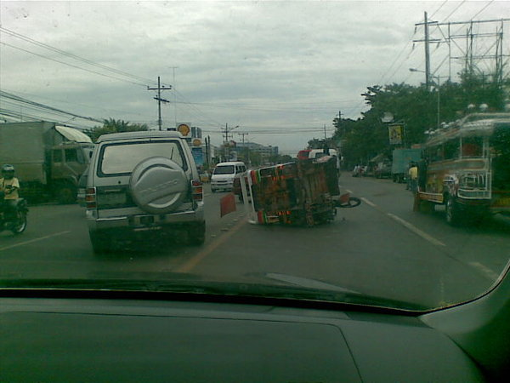
Figure 1-1: Car Accident Scene
Figure 1-1 shows how a car accident would look like. As seen in the figure, the vehicle is in a horrible position and is causing a disturbance in traffic. Aside from that, no traffic administrator, police authority or ambulance is seen present in the picture. This emphasizes the dire need of a traffic accident management information system.

  - Statement of the Problem
Through the research, observations and experiences of the proponents on traffic systems especially in third world countries, the proponents were able to formulate several problems. The main problem is that there is usually no direct in-charge entity to call to when a traffic accident occurs. Another problem is the lack of information of people on what to do or who to call or text. Traffic accidents also cause traffic congestion which is a problem for commuters and can affect the economy. A lot of people involved in traffic accidents die even though he or she would have been saved if the ambulance, traffic administrators, and police authorities were quicker to respond to the accident.

  - Objectives of the Study
    - General Objective
The research aimed to gather data on how the traffic administrators, police authorities, and hospitals respond to a traffic accident and develop a traffic accident management information system.
    - Specific Objectives
This thesis specifically aims to accomplish the following:
- To gather data like confidentiality policies, traffic accidents standard operating procedures and contact details from the following local entities: Traffic Administration Offices, Police Departments, and Hospitals,
- To gather information on how these entities respond to traffic accidents,
- To identify procedures on how these three entities communicate with the immediate relation or contact person of the injured person involved in the accident,
- To develop a web-based traffic accident management information system,
- To pilot test the system and evaluate the SMS broadcasting functionality through the scoring rubric made for this purpose.

  - Scope and Limitation
The study will be limited to traffic accident reports and data gathered from the three entities within Cagayan de Oro City. The system will only address traffic accidents categorized as vehicles colliding with another vehicle, pedestrian, or other stationary obstructions and that it results in traffic congestion, injury, death, vehicle damage and property damage. And lastly, there is a possibility of lack of identification from the injured person involved in the traffic accident. Lack of this certain data will hinder the system in informing or providing information for the family or relatives of a person involved in a traffic accident. This information is crucial because hospitals, specifically private hospitals, do not admit patients without his or her identification details and signature or the presence and signature of an immediate relation. This results in the failure of the system to save certain lives. The system to be made will not be capable yet to provide effective countermeasures to this problem.

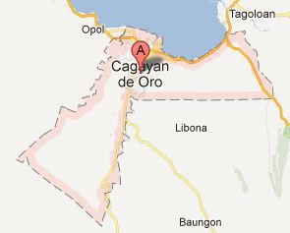Figure 1-2: A Map of Cagayan de Oro City. Acquired through Google Maps
Figure 1-2 shows the border of a map of Cagayan de Oro City. Only entities located within this border are to be included in the study.

  - Significance of the Study
This study aims to develop a Traffic Accident Management Information System (TAMIS). The study was proposed to make a significant impact on traffic accidents occurring especially in Cagayan de Oro City where it will be implemented. This claim is backed by the related literatures reviewed by the proponents. It is a web-based system that would hopefully improve the coordination between the key entities which are the traffic administration, police authority, and hospitals. This means that there would be a faster response speed of these entities increasing the probability of saving lives and preventing traffic congestion. TAMIS will be able to stand on its own and not rely on other entities. It can acquire traffic accident reports from calls and texts, which is the common mode of communication nowadays, from traffic accident witnesses or on-scene responders. One of its significant features will be that it can inform simultaneously the key entities in the event of a traffic accident within Cagayan de Oro. It will be a means to automate the recording of traffic accident reports and store it in a database. This will remove the limits of only having hard copy data. And through the data gathering and storing function of the system, traffic accident prone road areas will be accurately determined and properly monitored and the frequency of traffic accidents can also be monitored. People can easily visit the TAMIS website and view the information they need. Any community would benefit from it because of its helpful functions and features.

  - Basic Concepts and Terminologies
Traffic Accident
- The term accident is commonly accepted as an occurrence involving one or more transportation vehicles in a collision that results in property damage, injury, or death.
- The term accident implies a random event that occurs for no apparent reason than “it just happened”.
- Accident is used to describe things that happen unintentionally, in other words, accidentally.
Traffic Incident
Incident has a wider meaning and can be used both for accidents and for intentional actions such as crimes.
Key Entities
Establishments or government offices involved or are responsible in handling traffic accidents namely: Traffic administration Offices, Police departments, and Hospitals.
Traffic Accident Management Information System (TAMIS)
This is the system the proponents will create in order to solve the traffic accident problem in Cagayan de Oro City. The system will be able to store traffic accident data, generate reports, send Short Message Service (SMS) Alerts to key entities thereby improving coordination and response speed of the Cagayan de Oro community. It will also serve as an information site for those who are ignorant on what to do during traffic accidents.

